Type of Article (Original Article / Review Article / Short Communication) (Size 11)

Instructions to Authors Preparing Their
Camera Ready Papers for Conference A4 Page Size (Size 24)

First Author¹, Second Author², Third Author³ (Size 11) No abbreviations allowed, No more prefixes like Dr, Prof, Er, etc only name should be mention

¹Author designation, Department, University or college Name, State, Country Name. (Size 10 &italic)
²Author designation, Department, University or college Name, State, Country Name. (Size 10 &italic)
³Author designation, Department, University or college Name, State, Country Name. (Size 10 &italic)

¹corresponding.author@mailserver.com, ²coauthor@mailserver.com, ³coauthor@mailserver.com (Size9)
( maximum three author mail id allowed not more than that )

Received Date: DD MM YYYY ( To be filled by editorial team )
Revised Date: DD MM YYYY ( To be filled by editorial team )
Accepted Date: DD MM YYYY ( To be filled by editorial team )

Abstract (Size 10 & Italic) — This document gives formatting instructions for authors preparing papers for publication in the Proceedings of an Journal. The authors must follow the instructions given in the document for the papers to be published. You can use this document as both an instruction set and as a template into which you can type your own text. The abstract must clearly state the novelty of the work regarding the journal fields. Do not use more than 200 words in the abstract, as it will be included in the on-line version of the journal and sent for indexing to international databases, in different formats. Very careful wording should be used in the title and in the abstract. Without a proper title and abstract, a great paper might never be downloaded and/or read.
Keywords (Size 10 & Italic) — five keywords or phrases arranged alphabetically and separated by commas. A list of keywords may be found on the website. Use only the keywords defined there.
I. INTRODUCTION (SIZE 10 &BOLD)
(Size 10 & Normal)This document is a template. These instructions provide basic guidelines to help authors prepare their final camera-ready papers for submission to International Journal of Agriculture & Environmental Science. Prospective authors are invited to submit papers that fit within the scope of the journal. Papers should be written in English and submitted in final camera-ready form. All text has to be edited by using the styles defined in this document.
Do not use blank lines for spacing. Re-arrange the text in order to fit all the blanks. Do not use blank lines for spacing. Re-arrange the text in order to fit all the blanks.
This work was supported in part by the E.U. Commission under Grant EUV13/20160727/AE (sponsor and financial support acknowledgement go here - modify or delete this note if it is not the case).
It is mandatory to submit your original work in Microsoft Word format (.DOC) or in Portable Document Format (.PDF). We will do only minor corrections and the final formatting of your paper.
II. PAGE LAYOUT(SIZE 10 &BOLD)
(Size 10 & Normal)Do not change the font sizes or line spacing to squeeze more text into a limited number of pages. Use italics for emphasis; do not underline.
To insert images in Word, position the cursor at the insertion point and either use Insert | Picture | From File or copy the image to the Windows clipboard and then Edit | Paste Special | Picture (with “Float over text” unchecked).
You are kindly advised to use this template for editing your submission, as you have nothing to change in terms of paper and text format. Simply applying the styles defined here will be sufficient - it should take no more than 5 to 10 minutes per page.
Author name, affiliation and complete address are to be placed underneath the title. In the case of multiple authorship of a submitted paper, the affiliation and complete address of each author must be specified.
A. Page Layout(Size 10 & Bold &Italic)
Your paper must use a page size corresponding to A4 which is 8.5" wide and 11" long. The margins must be set as follows:
  - Top = 1"
  - Bottom = 1"
  - Left = Right = 0.7"
  - Header = Footer = 0.5"
Your paper must be in two-column format with a space of 0.25" between columns.
III. PAGE STYLE(SIZE 10 &BOLD)
All paragraphs must be indented. All paragraphs must be justified, i.e. both left-justified and right-justified.
- Text Font of Entire Document(Size 10 & Bold & Italic)
The entire document should be in Times New Roman. Type Other font types may be used if needed for special purposes.
Recommended font sizes are shown in Table 1.
- Title and Author Details(Size 10 & Bold &Italic)
The title must be in 24 pt Regular font. Author name must be in 11 pt Regular font. Author affiliation must be in 10 pt Italic. The email address must be in 9 pt Regular font.
All title and author details must be in single-column format and must be centered.
Every word in a title must be capitalized except for short minor words such as a, an, and, as, at, by, for, from, if, in, into, on, or, of, the, to, with.
Author details must not show any professional title (e.g. Managing Director), any academic title (e.g. Dr.) or any member of any professional organization (e.g. Senior Member).
To avoid confusion, the family name must be written as the last part of each author name (e.g. John A.K. Smith).
Each affiliation must include, at the very least, the name of the company and the name of the country where the author is based (e.g. Causal Productions Pty Ltd, Australia).
Email address is compulsory for the corresponding author.
A. Section Headings(Size 10 & Bold &Italic)
No more than 3 levels of headings should be used. All headings must be in 10pt font. Every word in a heading must be capitalized except for short minor words as listed in Section III-B.
a) Level-1 Heading: (Size 10 & Bold & Italic) A level-1 heading must be in Upper Caps, centered and numbered using uppercase Roman numerals. For example, see heading ―III. Page Style of this document. The two level-1 headings which must not be numbered are―Acknowledgment and ―References.
b) Level-2 Heading: (Size 10 & Bold & Italic)A level-2 heading must be in Italic, left-justified and numbered using an uppercase alphabetic letter followed by a period. For example, see heading―C.Section Headings above.
c) Level-3 Heading: (Size 10 & Bold & Italic) A level-3 heading must be indented, in Italic and numbered with an Arabic numeral followed by a right parenthesis. The level-3 heading must end with a colon. The body of the level-3 section immediately follows the level-3 heading in the same paragraph. For example, this paragraph begins with a level-3heading.
B. Figures and Tables(Size 10 & Bold &Italic)
(Size 10 & Normal)Figures and tables must be centered in the column. Large figures and tables may span across both columns. Any table or figure that takes up more than 1 column width must be positioned either at the top or at the bottom of the page.
Please use only SOLID FILL colors, which contrast well both on screen and on a black-and-white hardcopy, as shown in Fig.1.
Fig. 1 A sample line graph using colors that contrast well both on screen and on a black-and-white hardcopy
Fig. 2 shows an example of a low-resolution image that would not be acceptable, whereas Fig. 3 shows an example of an image with adequate resolution. Check that the resolution is adequate to reveal the important detail in the figure.
(Size 10 & Normal)Please check all figures in your paper both on screen and on a black-and-white hardcopy. When you check your paper on a black-and-white hardcopy, please ensure that:
- the colors used in each figure contrast well,
- the image used in each figure is clear,
- All text labels in each figure are legible.

C. Figure Captions(Size 10 & Bold &Italic)
(Size 10 & Normal)Figures must be numbered using Arabic numerals. Figure captions must be in 10 pt bold font. Captions of a single line (e.g. Fig. 2) must be centered, whereas multi-line captions must be justified (e.g. Fig. 1). Captions with figure numbers must be placed after their associated figures, as shown in Fig.1.
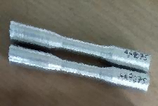
Fig. 2 Example of low-resolution image (Don’t use like this)
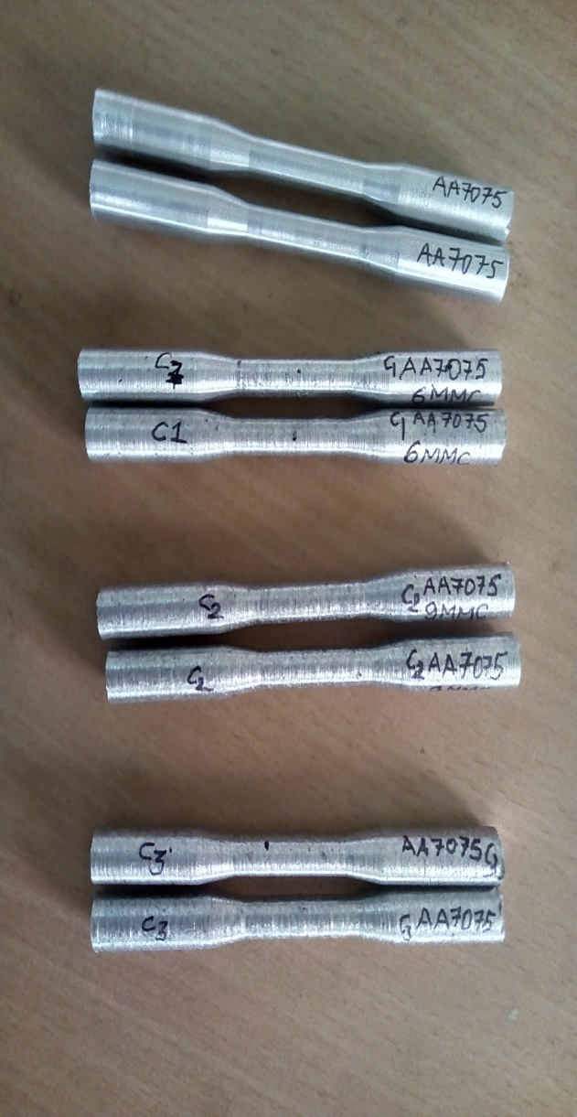
Fig. 3 Image with adequate resolution. If necessary, the images can be extended to both columns
D. Table Captions(Size 10 & Bold &Italic)
Tables must be numbered using uppercase Arabic numerals. Table captions must be centered and in 10 pt bold font with Small Caps. Every short minor word is listed in Section III-B. Captions with table numbers must be placed before their associated tables, as shown in Table1.

Table 1. Font sizes for papers
Font Size | Appearance (in Time New Roman)
Font Size | Regular | Bold | Italic
8 | reference item |  | reference item (partial)
9 | author email address
10 | level-1 heading (in Small Caps), paragraph | abstract heading | level-2 heading, level-3 heading, author  affiliation,  abstract body
11 | author-name
24 | title

E. Page Numbers, Headers and Footers(Size 10 &Bold &Italic)
Page numbers, headers and footers must be used as it in the template.
F. Links and Bookmarks(Size 10 & Bold &Italic)
(Size 10 & Normal)All hypertext links and section bookmarks will be removed from papers during the processing of papers for publication. If you need to refer to an Internet email address or URL in your paper, you must type out the address or URL fully in Regular font.
G. Some Common Mistakes
The word “data” is plural, not singular. The subscript for the permeability of vacuum µ0 is zero, not a lowercase letter “o.” Use the word “micrometer” instead of “micron.” A graph within a graph is an “inset,” not an “insert.” The word “alternatively” is preferred to the word “alternately” (unless you really mean something that alternates). Use the word “whereas” instead of “while” (unless you are referring to simultaneous events). Do not use the word “essentially” to mean “approximately” or “effectively.” Do not use the word “issue” as a euphemism for “problem.” Be aware of the different meanings of the homophones “affect” (usually a verb) and “effect” (usually a noun), “complement” and “compliment,” “discreet” and “discrete,” “principal” (e.g., “principal investigator”) and “principle” (e.g., “principle of measurement”). Do not confuse “imply” and “infer”.
Prefixes such as “non,” “sub,” “micro,” “multi,” and “ultra” are not independent words; they should be joined to the words they modify, usually without a hyphen. There is no period after the “et” in the Latin abbreviation “et al.” (it is also italicized). The abbreviation, “i.e.,” means “that is,” and the abbreviation “e.g.,” means “for example” (these abbreviations are not italicized).
H. References
(Size 10 & Normal)The heading of the References section must not be numbered. All reference items must be in 8 pt font. Please use Regular and Italic styles to distinguish different fields, as shown in the References section. Number the reference items consecutively in square brackets (e.g.[1]).
When referring to a reference item, please simply use their reference number, asin[2]. Do not use―Ref.[3]or
―Reference[3]except at the beginning of a sentence, e.g.
―Reference [3] shows …. Multiple references are each numbered with separate brackets (e.g. [2], [3], [4]–[6]).

VI. CONCLUSION (SIZE 10 &BOLD)
A conclusion section is not compulsory, but we recommend it. Although a conclusion may review the main points of the paper, do not replicate the abstract as the conclusion. A conclusion might elaborate on the importance of the work or suggest applications and extensions. Try to emphasize your scientific contribution and the differences from previous works in the literature. The conclusion is a text-only section - do not use equations, graphs or cite references in this section. Make sure that the whole text of your paper observes the textual arrangement on this page.

APPENDIX A
Appendices, if present, must be marked A, B, C, and placed before the Acknowledgment section.

ACKNOWLEDGMENT (SIZE 10 & BOLD)
Place your acknowledgements before References. Do not mention the sponsors and/or financial support obtained in this section, as they must be included in an unnumbered footnote on the first page of the paper. You have to delete the footnote on the first page if there is no sponsorship information to add.
REFERENCES (FONT SIZE 10 & BOLD)
(Authors are requested to follow the reference format in a strict manner)
Examples of reference items of different categories shown in the References section include:
- example of a book in[1]
- example of a book in a series in[2]
- example of a journal article in[3]
- example of a conference paper in[4]
- example of a patent in[5]
- example of a website in[6]
- example of a web page in[7]
- example of a data book as a manual in[8]
- example of a datasheet in[9]
- example of a master’s thesis in[10]
- example of a technical report in[11]
- (Font Size 8) S. M. Metevand V. P. Veiko, Laser Assisted Microtechnology, 2nd ed., R. M. Osgood, Jr., Ed. Berlin, Germany: Springer-Verlag. 5(3) (1998) 300-320.
- J. Breckling, Ed., The Analysis of Directional Time Series: Applications to Wind Speed and Direction, ser. Lecture Notes in Statistics. Berlin, Germany: Springer. 61(1) (1989) 200-220.
- S. Zhang, C. Zhu, J. K. O. Sin, and P. K. T. Mok, A novel ultrathin elevated channel low-temperature poly-Si TFT, IEEE Electron Device Lett. 20(4) (1999) 569–571.
- M.Wegmuller,J.P.vonder Weid,P.Oberson and N.Gisin, High-resolution fiber distributed measurements with coherent OFDR, in Proc. ECOC’00, paper 11(3)(2000) 109-125.
- R. E. Sorace, V. S. Reinhardt, and S. A. Vaughn, ―High-speed digital-to-RFconverter, U.S.Patent5668842, 20(2) (1997) 300-325.
- (2002) The IEEE website. [Online]. Available: http://www.ieee.org/
- FLEX Chip Signal Processor(MC68175/D), Motorola, 15(3) (1996) 250-275.
- PDCA12-70 data sheet,OptoSpeedSA, Mezzovico, Switzerland.
- A. Karnik, Performance of TCP congestion control with rate feedback: TCP/ABR and rate-adaptive TCP/IP, M. Eng. thesis, Indian Institute of Science, Bangalore, India. 7(6) (1999) 450-465.
- J. Padhye, V. Firoiu, and D. Towsley, A stochastic model of TCP Reno congestion avoidance and control, Univ. of Massachusetts, Amherst, MA, CMPSCI Tech. Rep. 8(4) (1999) 99-120.
- Wireless LAN Medium Access Control (MAC) and Physical Layer (PHY) Specification, IEEE Std. 12(11) (1997) 260-280.
At least 25 quality Journal references should be cited

